

**“CERTIFICATE”**

This is to certify that the skill project entitled “**WEB CONTROLLED NOTIFICATION USING RASPBERRY PI**” being submitted by the following students in partial fulfilment of the requirements for the award of degree of Bachelor of Technology in Computer Science and Engineering at Government College of Engineering Kalahandi, Bhawanipatna is carried out by them under our supervision.

To the best of knowledge, the matter embodied in the report has not been submitted to in any other university for the award of any degree of diploma.

SATISH RANJAN ROUT 1701110081

ROHIT SHANKAR PANIGRAHI 1701110120

SHAHEEL SAHOO 1701110158

SUBHRANSU SEKHAR SAHOO 1701110012

SARVESH DASGUPTA 1701110053

Prof. D.R. NAYAK

(H.O.D. CSE)

**DECLARATION**

We hereby certify that the work presented in the project report “**WEB CONTROLLED NOTIFICATION USING RASPBERRY PI**” being submitted to Dept. of Computer Science and Engineering, Government College of Engineering ,Kalahandi in partial fulfilment of requirements for the award of Bachelor of Technology in Computer Science and Engineering under Biju Pattnaik University of Technology, Rourkela is a record of *bona-fide* work carried out by them.

The matter presented in this project report has not been submitted by us for the award of any other degree.

SATISH RANJAN ROUT 1701110081

ROHIT SHANKAR PANIGRAHI 1701110120

SHAHEEL SAHOO 1701110158

SUBHRANSU SEKHAR SAHOO 1701110012

SARVESH DASGUPTA 1701110053

**“**ACKNOWLEDGEMENT**”**

With immense pleasure we, the group members presenting “**WEB CONTROLLED NOTIFICATION USING RASPBERRY PI**” skill project report is the part of a curriculum of Computer Science and Engineering. We wish to thank all the persons who gave us an unending support.

We express our profound thanks to **H.O.D**. ***Prof. D.R. NAYAK***, and all the faculty members those who have indirectly guided and help us in preparation of this skill project.

SATISH RANJAN ROUT 1701110081

ROHIT SHANKAR PANIGRAHI 1701110120

SHAHEEL SAHOO 1701110158

SUBHRANSU SEKHAR SAHOO 1701110012

SARVESH DASGUPTA 1701110053

“A B S T R A C T”

Notice boards are playing very important role in ourday to day life. By replacing conventional Analog type notice board with digital notice board, we can make information dissemination much easier in a paperless community. Here the admin can control notice board through internet. So, information can be sent anywhere in the world and can be displayed within seconds. Information may be in the form of text, image, pdf etc. PC is used for sending information and Raspberry pi is connected to internet at the receiving side. In addition to this a website which will be present on the admin’s mobile phone/PC can serve the same purpose.

C O N T E N T S

|  |  |  |
| --- | --- | --- |
| SL NO. | TOPICS | PAGE NO |
| 1 | Certificate | 01 |
| 2 | Declaration | 02 |
| 3 | Acknowledgement | 03 |
| 4 | Abstract | 04 |
| 5 | Contents | 05 |
| 6 | Introduction | 06-07 |
| 7 | Specific Requirements | 08 |
| 8 | Overview of Project | 09 |
| 9 | Basic Block Diagram | 10 |
| 10 | Implementation of Notice Board | 11-13 |
| 11 | Screenshots | 14-18 |
| 12 | Future Scope | 19 |
| 13 | Conclusion | 20 |
| 14 | References | 21 |

**I N T R O D U C T I O N**

Notice board is an essential information gathering system in our life. In our day-to-day life we can see notice boards in various places like, educational institutions, railway stations, shopping malls, Bus stations, offices etc. So, we can say that Notice boards are the places to leave public information such as advertise events, announce events or provide attention to the public, etc. Now days Separate person is needed to stick that information on the notice board. It will lead to lose of time as well as usage of manpower. In conventional analog type notice boards paper is the main medium for information exchange. We know that information counts are endless. So, there is a usage of huge amount of paper for displaying those endless counts of information. The problems faced by the wooden or conventional type notice boards are resolved by the implementation of our digital notice board. It will bring an advanced means of passing notices around in the world in a much easier and efficient way. Due to the popularity of internet, we choose internet as a medium for transferring information. The Internet of things (IoT) is the network of physical devices, vehiclesone appliances and other items embedded with electronics. Software, which enables these objects to connect and exchange data. Each device is uniquely identifiable through its Embedded computing system but is able to inter operate within the existing Internet infrastructure for providing security, we add username and password type authentication system. So only respective authority can send information. Raspberry pi which is the Heart of our system. A monitor is interfaced with Raspberry Pi. So, information in the form of text, image and pdf can display on the large screens. Our primary aim is to get more people’s attention on the display. By the usage of high definition display devices people can get more attention on the notice board rather than conventional notice boards. In conventional wireless notice board can display only texted messages. But in our newly implemented system can display images and pdf documents in addition to text messages. Because in Educational institutions majority of information given from the higher authorities in the form of images or pdf format. So, displaying these types of information make our system more user friendly. Due to the utilization of internet the sender can send message anywhere in the world. There is no range limitation for the successful exchange of information.

*Need of Electronic Notice Board*

Notice board is a primary thing in any institution/organization or public utility places like bus stations, railway stations etc. But sticking various notices day to day is a hectic process.

A separate person is required to deal with this project. This project deals about an advanced hi-tech wireless notice board. An authenticated person can send a message from a remote place which is visible from LED/LCD Monitor.

S Y S T E M R E Q U I R E ME N T S

H A R D W A R E

Raspberry pi

HDMI to VGA

Ethernet cable

X64 bit Monitor

USB Cable

MicroSD Card 8GB

S O F T W A R E

Raspbian OS

Node JS

Python

HTML, CSS, Bootstrap, PHP

OpenWeather API& Others

**O V E R V I E W O F T H E P R O J E C T**

*System Description:*

* The proposed system is used to display the notifications,weather, time and news of the community.
* The main objective is to design,an automatic, self-enabled, highly reliable Web-Controlled electronic notice board.
* A display connected to a server system should continuously listen for the incoming notices or news from the client or user process it and display it on LCD Screen.
* Message displayed should be updated every time the user sends new data. The project deals with displaying news or notifications sent by the server.
* The server is fixed by setting up a local server on Raspberry Pi. An LCD Display is attached to Raspberry pi using HDMI Interface.
* Only authenticated people should be able to access the server. User should get an update every time the data is displayed on the monitor.

*Problem Solving Approach:*

* *To establish TCP/IP client server wireless connection*
* *Configure display side setup as Server*
* *WAMP Server is configured*
* *Configure user side setup as client*
* *To display the real time data on the LCD Screen*
* *Use Raspberry Pi as server*
* *Attach Raspberry Pi using HDMI with the LCD Screen*

**B A S I C B L O C K D I A G R A M**

CLOUD

CLOUD

ROUTER

WEBSITE LINKED

WIFI

ADAPTER

USB

INTERFACE

RASPBERRY PI

(ARM 7 Board)

HDMI

INTERFACE

POWER SUPPLY

LCD/LED

MONITOR

HARD DISK

SD CARD

**I M P L E M E N T A T I O N OF N O T I CE BOARD**

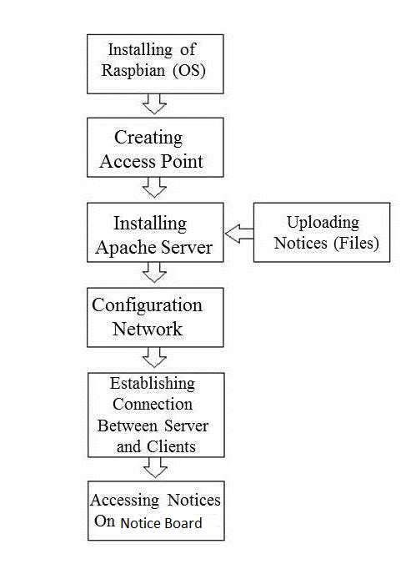

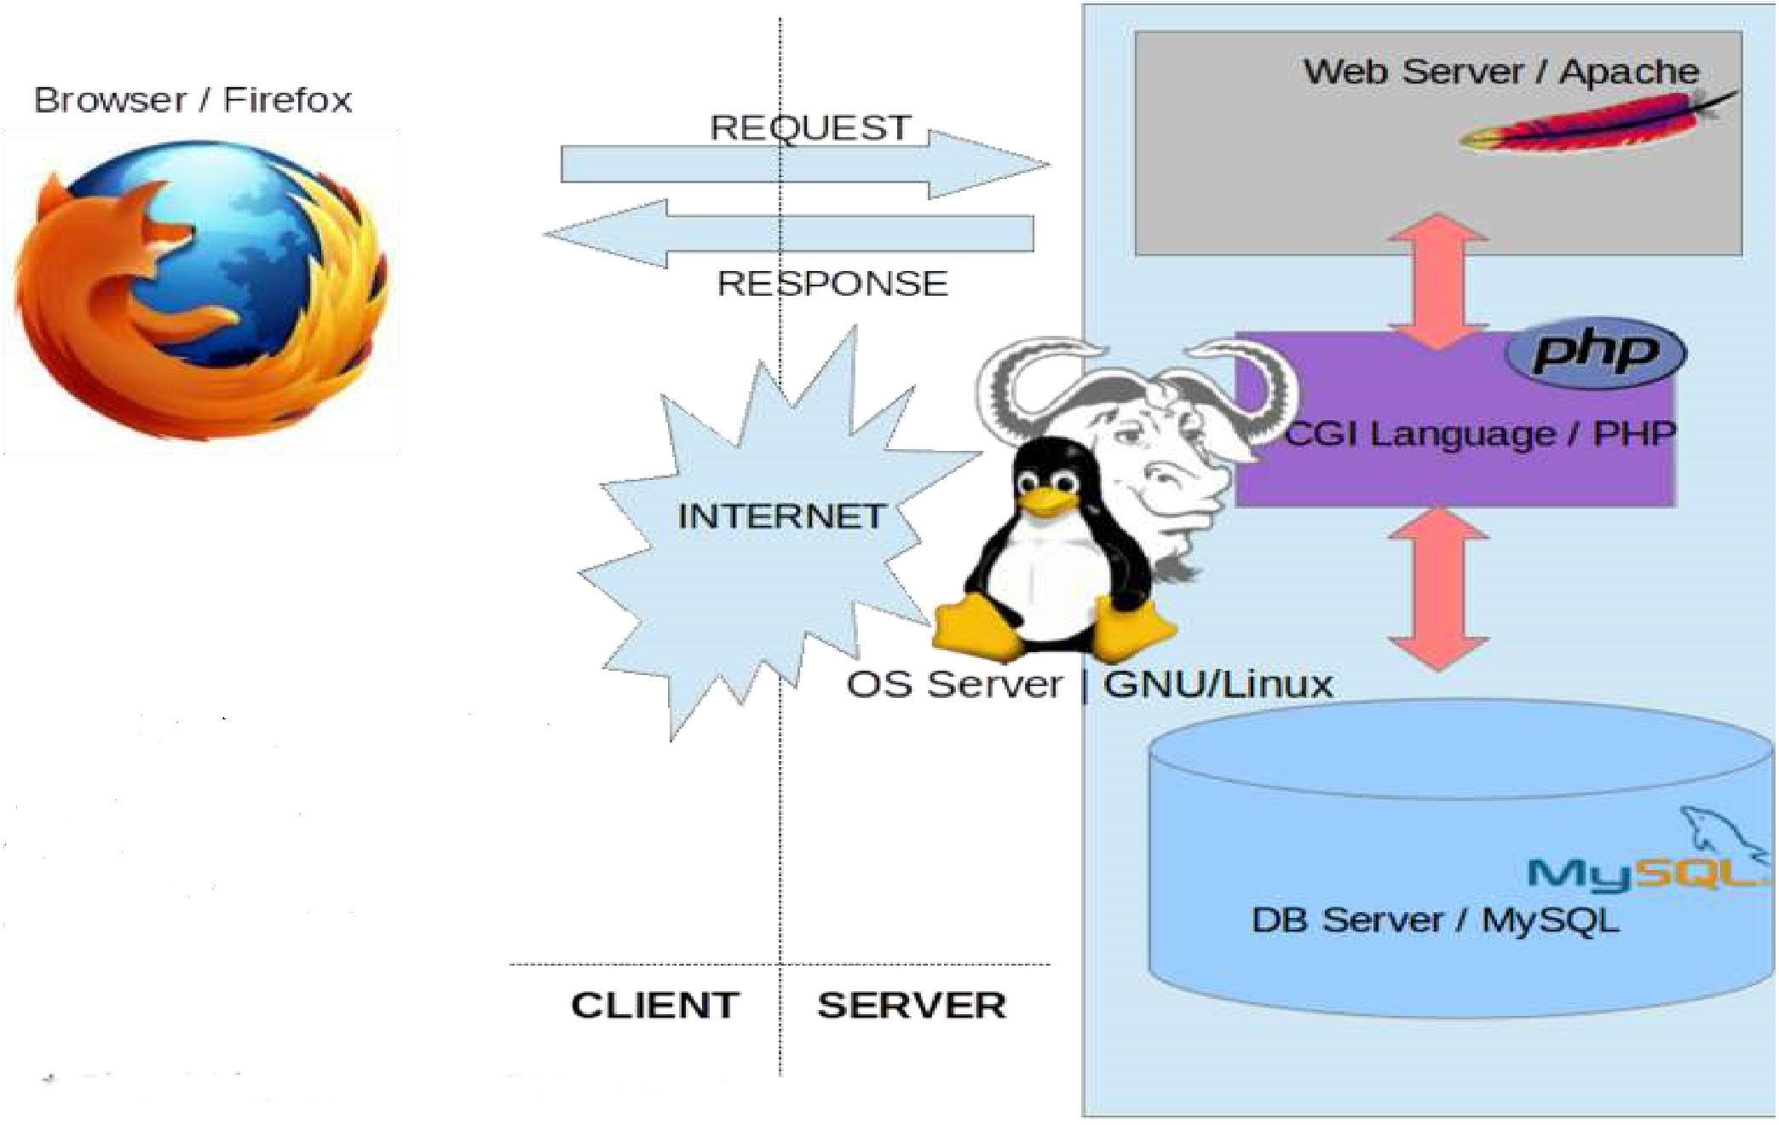

DFD

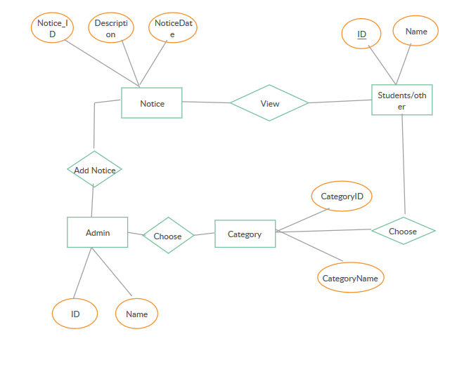

S C R E E N S H O T S

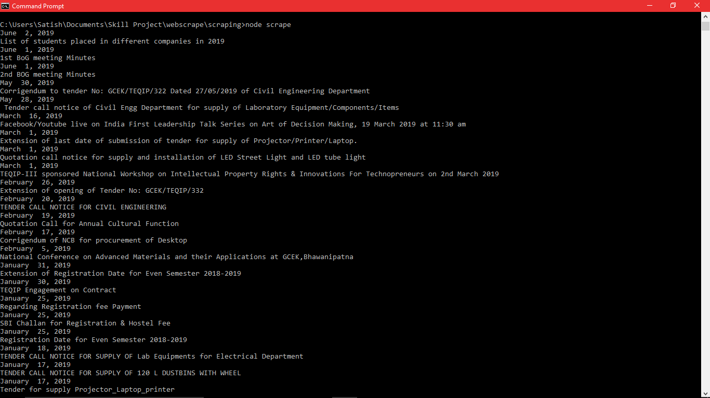

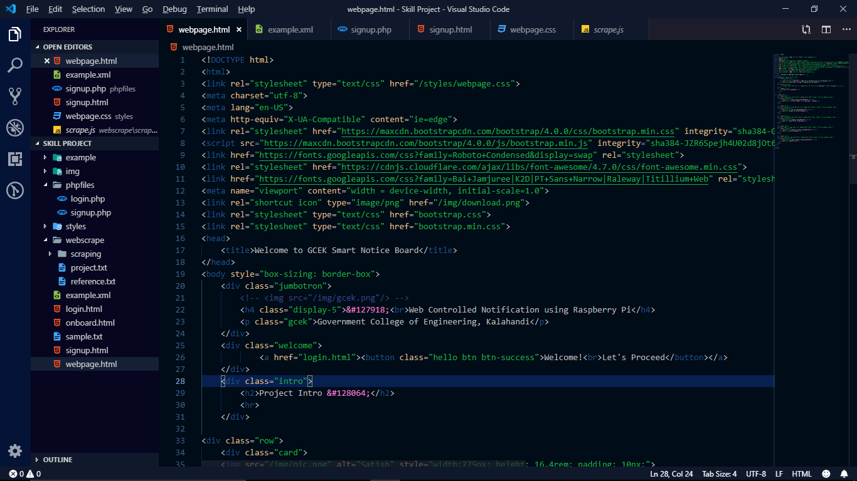

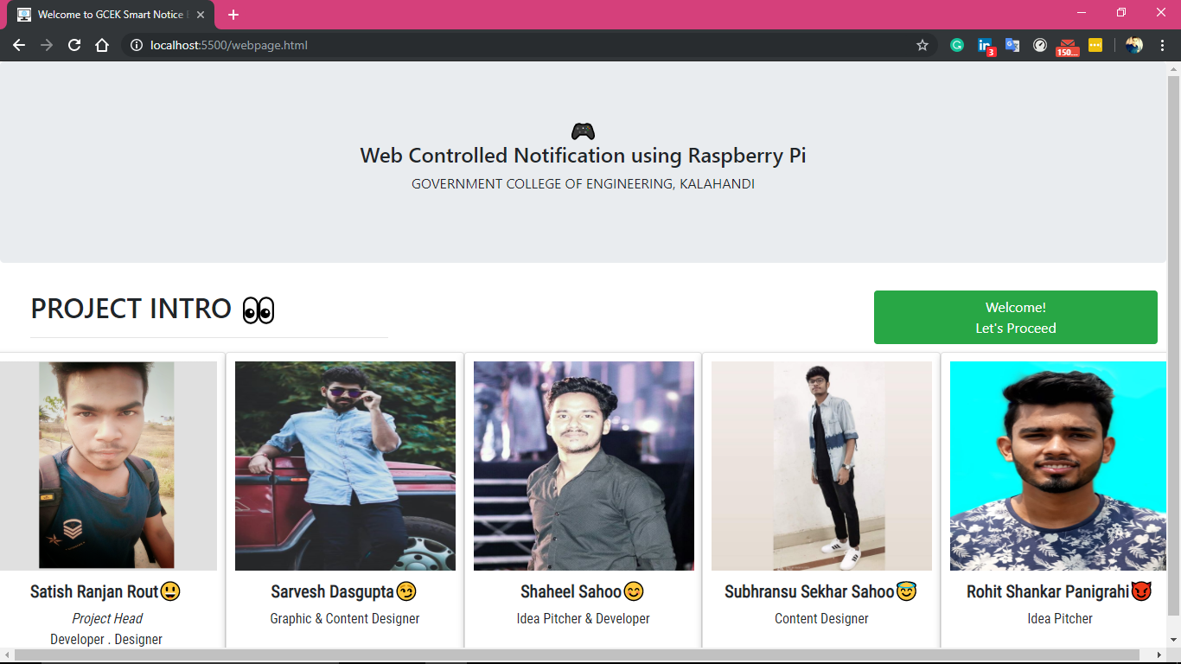

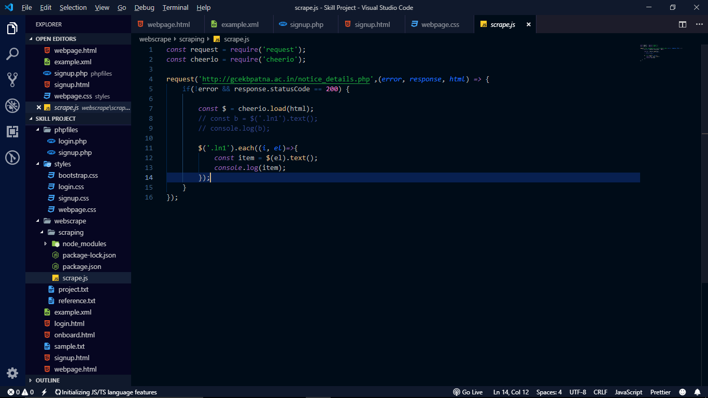

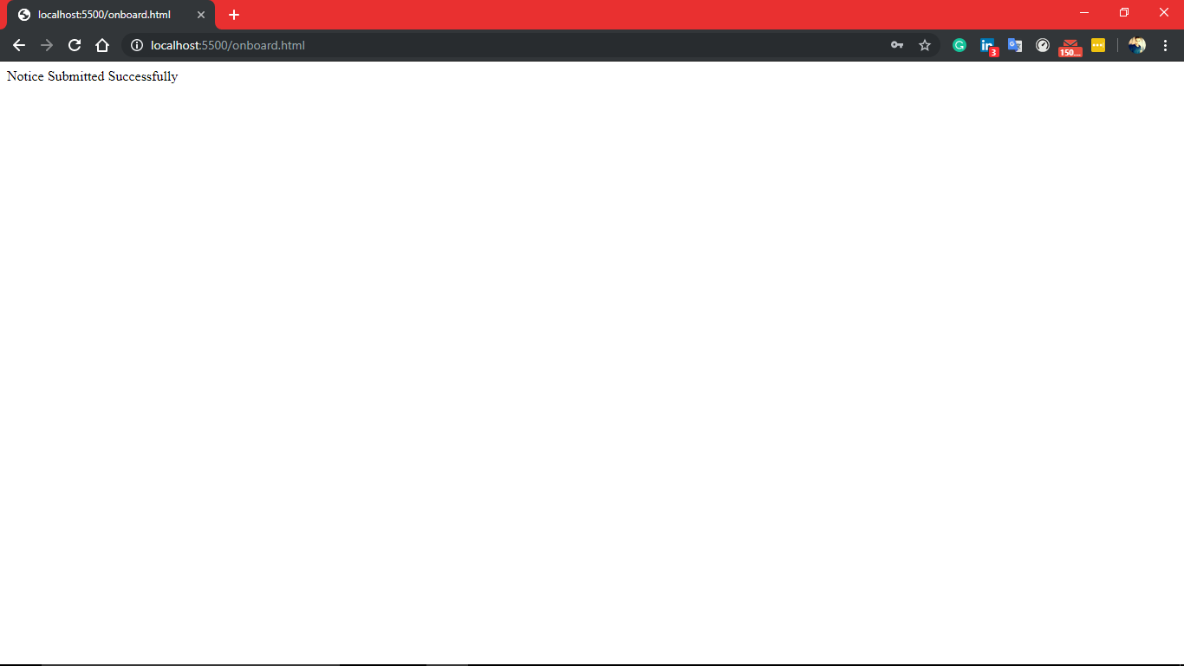

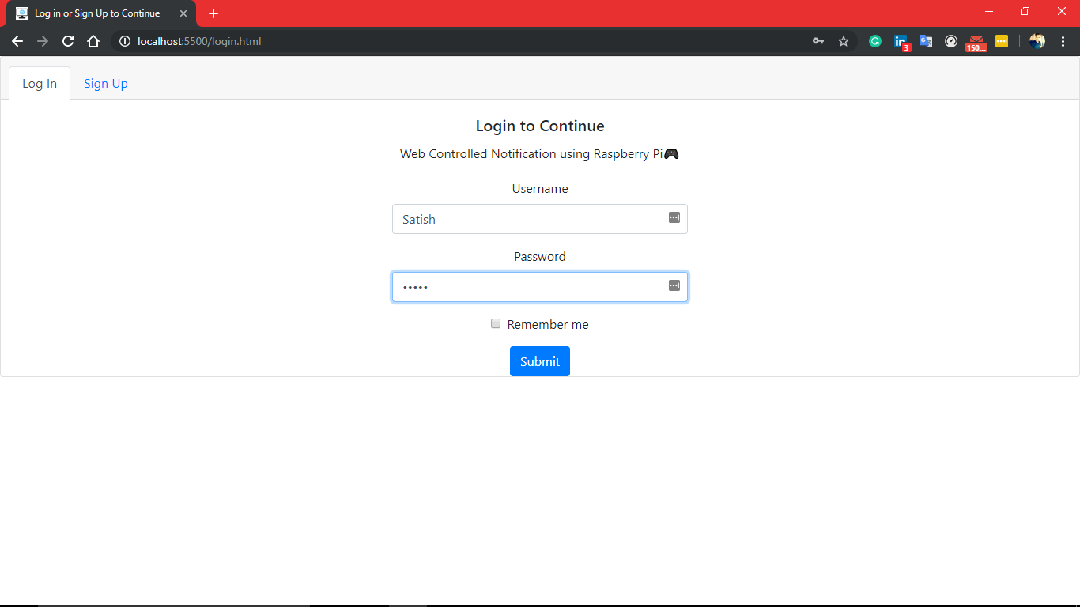

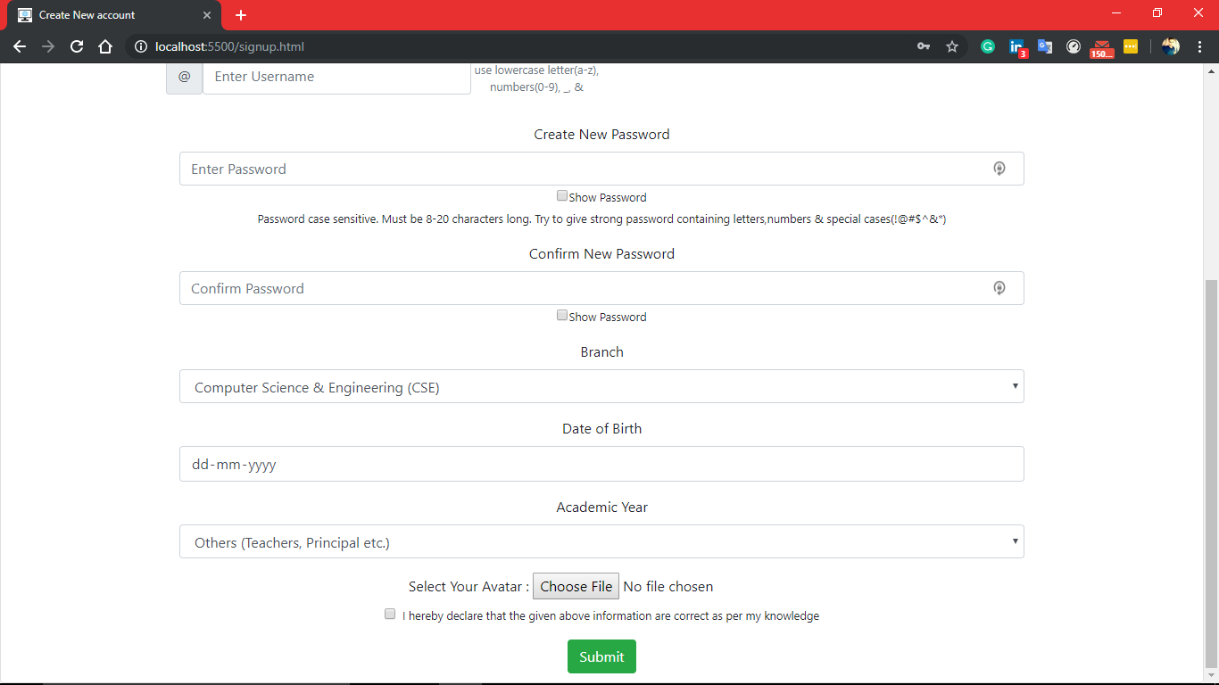

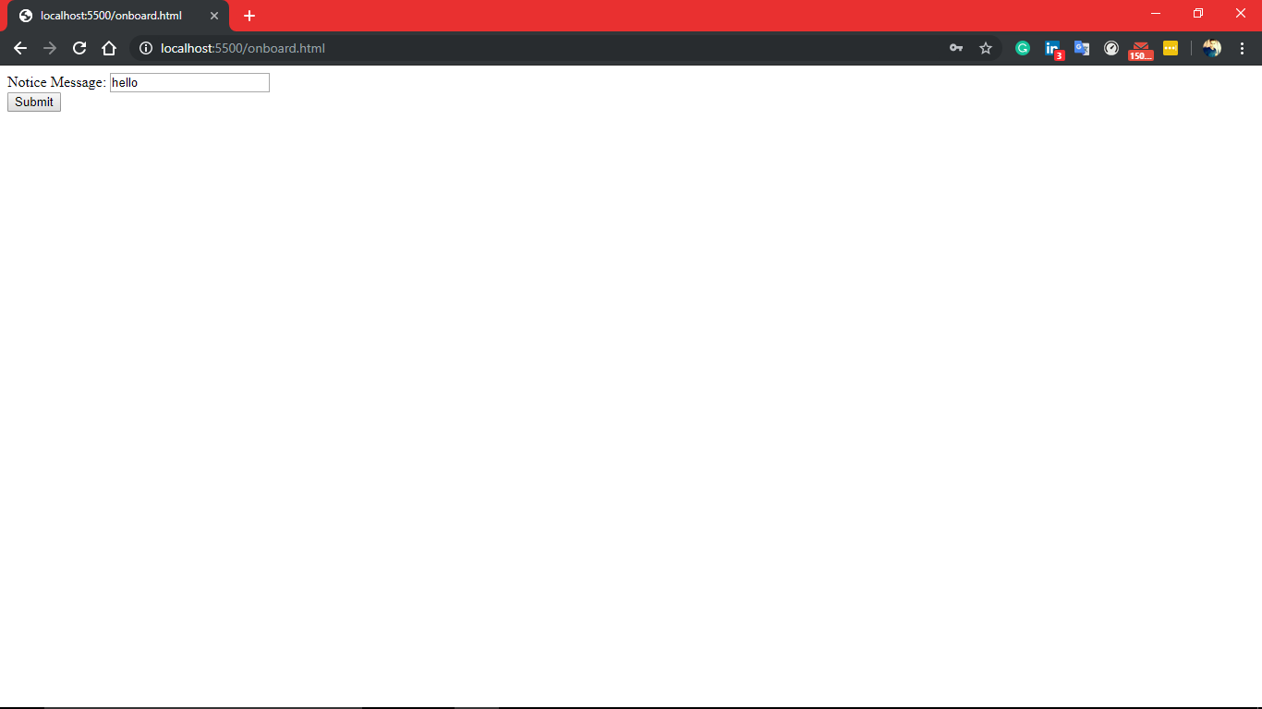

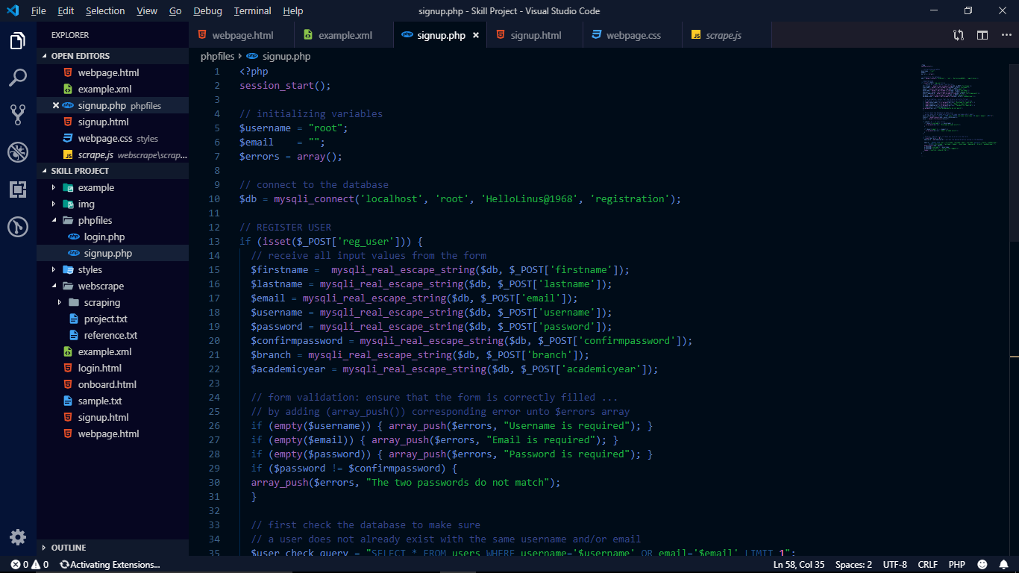

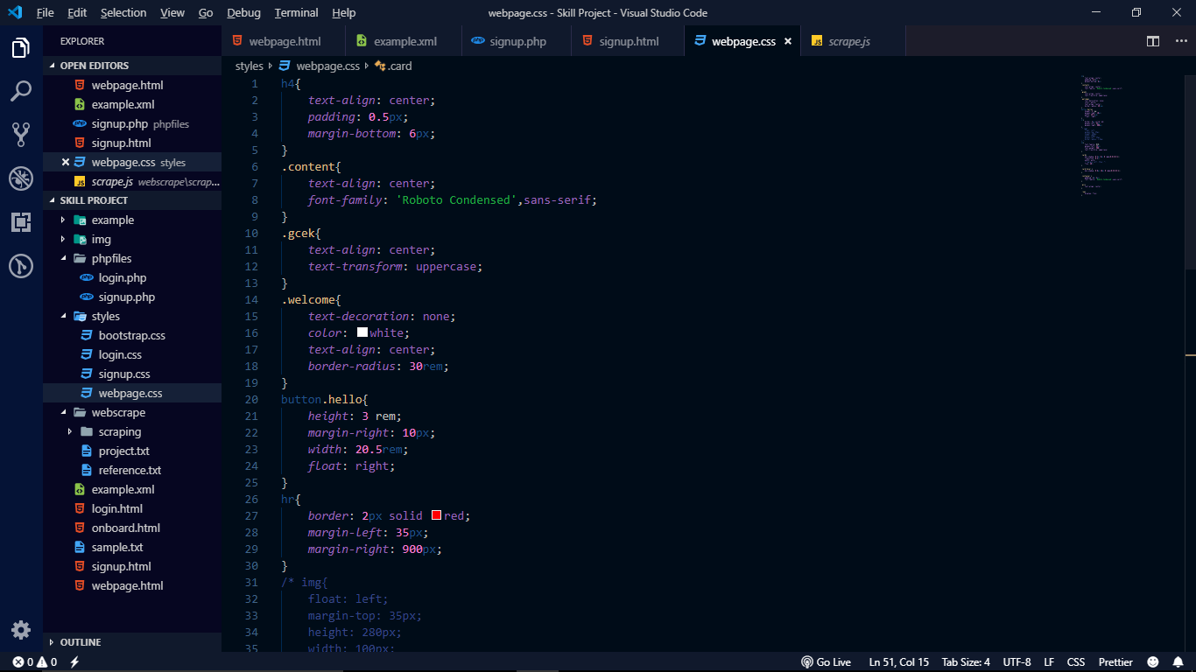

F U T U R E S C O P E

This system may be used for modification of notice boards and displaying news in the public areas or in institutions or organizations. Displaying news and weather information will be easy for people who are always in a rush. The don’t have to check by their phones or halt at a newspaper stand.

At home, if this notification is going to be implemented in a mirror, people won’t have to check any other sources for **“How’s the weather?”,“What’s the day today?”, “What are the festivals coming?”,**& especially **the news feed**.

**They’ll be updated & ready to go while being ready.**

**Web Controlled Notification System** can be used in any organisation or for self-use in home or any other sector.

By APIs and Widgets, this notification system is developed and **authorization access** assure the security.

**C O N C L U S I O N**

A **“WEB CONTROLLED NOTIFICATION USING RASPBERRY PI”** has been developed and the system was tested with the sample data.

The system results in regular timely preparations of required outputs.The system provides a user-friendly environment for the customers to check out the time news notifications etc.

It’ll also act as a home automation system if implemented in mirror like device to get the information.

**“R E F E R E N C E S”**

1. [**www.google.co.in**](http://www.google.co.in)
2. [**www.github.com**](http://www.github.com)
3. [**www.circuitdigest.com**](http://www.circuitdigest.com)
4. [**www.youtube.com**](http://www.youtube.com)
5. [**www.wikipedia.com**](http://www.wikipedia.com)